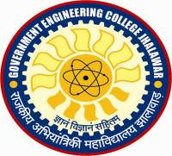
GOVERNMENT Engineering College JHALAWAR
TEQIP-III SPONSORED
FACULTY |DEVELOPMENT PROGRAMME ON TOPIC __________________________________
FROM: DATE _____________ to DATE _____________

VENUE: ____________________________
TENTATIVE PROGRAMME
DAY/DATE | Session –I  9:30 -11:00 AM | Session – II  11:15 AM – 12:45 PM | Session – III  1:45 PM – 3:15 PM | Session – IV  3:30 PM – 5:00 PM
Day & Date
Day & Date
Day & Date
Day & Date
Day & Date

Note: Breakfast timing from 8:30 to 9:30 am. First tea break from 11:00 am to 11:15 am, lunch from 12:45 to 1:45 pm and second tea break from 3:15 to 3:30 pm

